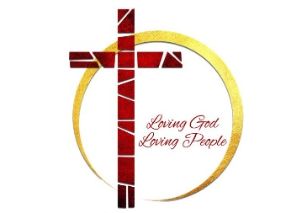
First Missionary Baptist Church
2026 HOLY CONSECRATION SCHEDULE
March 29th through April 5th

Holy Week Prayer and Fasting
“Daily renewal as we walk with Jesus through the most sacred days of His journey. Letting prayer soften the heart, letting fasting sharpen the spirit, and letting both draw us closer to God’s will.”

DAY 1 - March 29th
Palm Sunday — Surrender
Focus: Laying down what you’ve been carrying.
Prayer: “Lord, I release what keeps me from following You fully.”
Fasting posture: Let go of something that symbolizes control.

DAYS 2, 3, 4 - March 30th – April 1st
Monday–Wednesday — Cleansing
Focus: Letting God examine the heart.
Prayer: “Search me and make me clean.”
Fasting posture: Remove distractions so you can hear God clearly.

DAY 5 – April 2nd
Maundy Thursday — Humility
Focus: Serving and forgiving.
Prayer: “Make my heart like Yours—gentle, humble, willing.”
Fasting posture: Choose simplicity to make room for compassion.

DAY 6 – April 3rd
Good Friday — Brokenness
Focus: The weight of the cross.
Prayer: “Thank You for loving me at this cost.”
Fasting posture: A deeper fast (as your health allows) to honor the sacrifice.

DAY 7 – April 4th
Holy Saturday — Waiting
Focus: Silence, stillness, trust.
Prayer: “Even when I don’t see it, I trust You.”
Fasting posture: Quiet your environment and your mind.

DAY 8 – April 5th
Resurrection Sunday — Renewal
Focus: New life.
Prayer: “Raise in me what needs to live again.”
Fasting posture: Break the fast with gratitude and joy.

