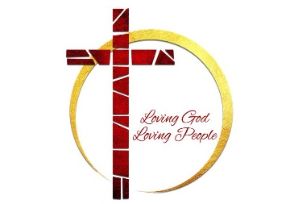

First Missionary Baptist Church
2026 HOLY CONSECRATION

“Daily renewal as we walk with Jesus through the most sacred days of His journey. Letting prayer soften the heart, letting fasting sharpen the spirit, and letting both draw us closer to God’s will.”

CORPORATE PRAYER TIMES

MARCH 29TH THROUGH APRIL 4TH

7AM PRAYER CALL
Number: 717-908-1834, Access Code: 254268#

APRIL 5TH

8AM PRAYING WITH THE PASTOR
Church Sanctuary

